Task01:

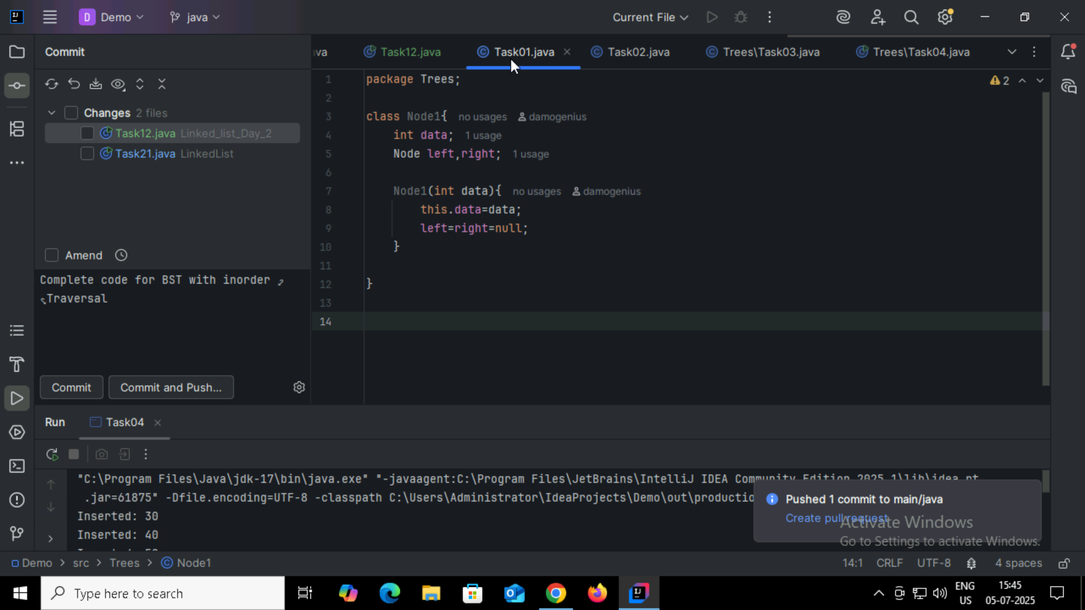

Task02:

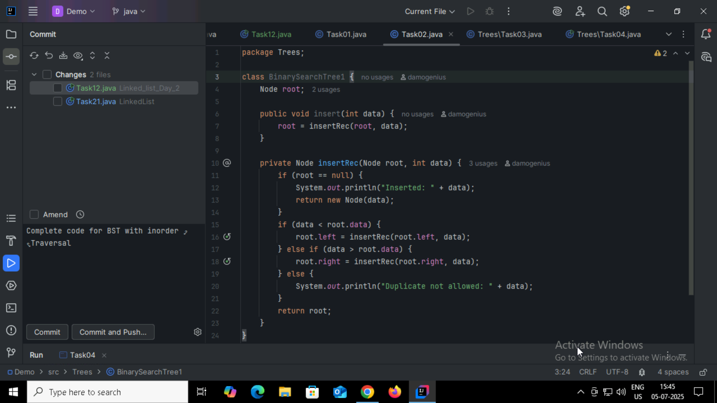

Task03:

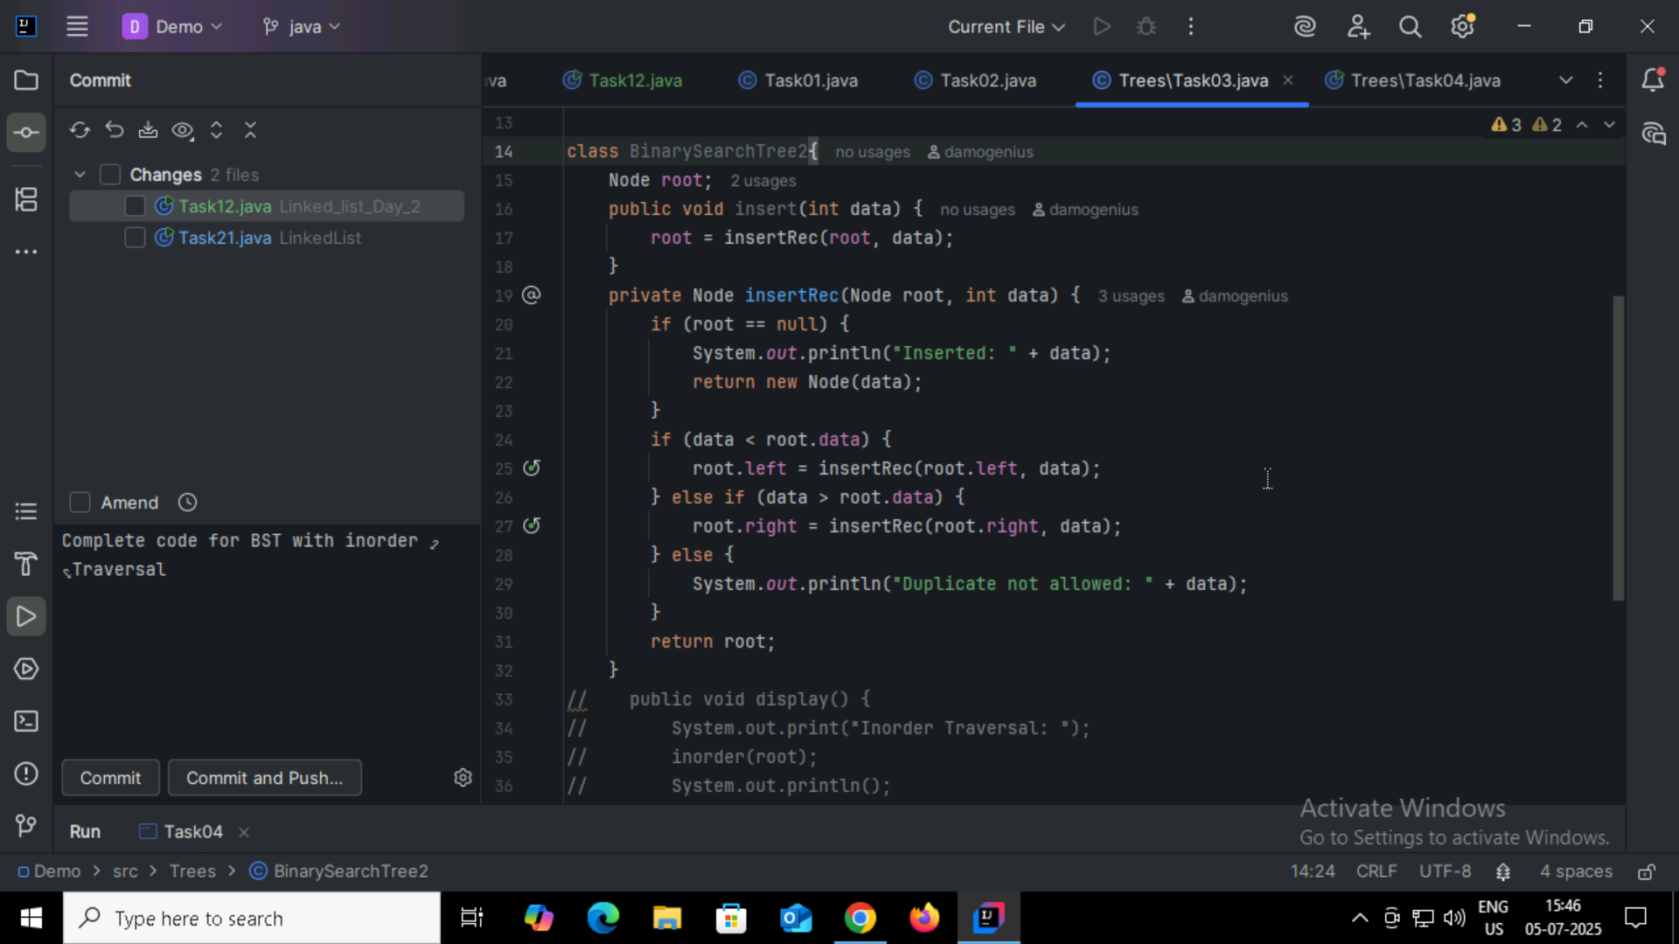

Task04:

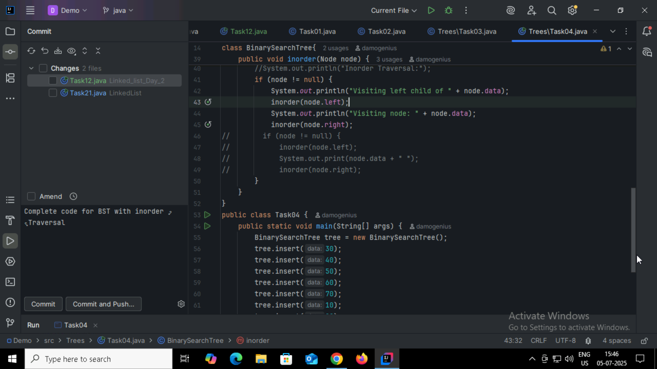

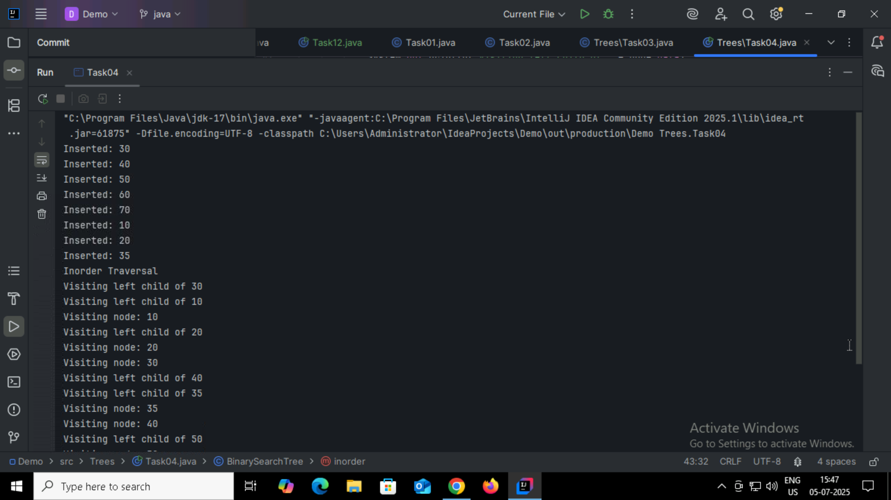

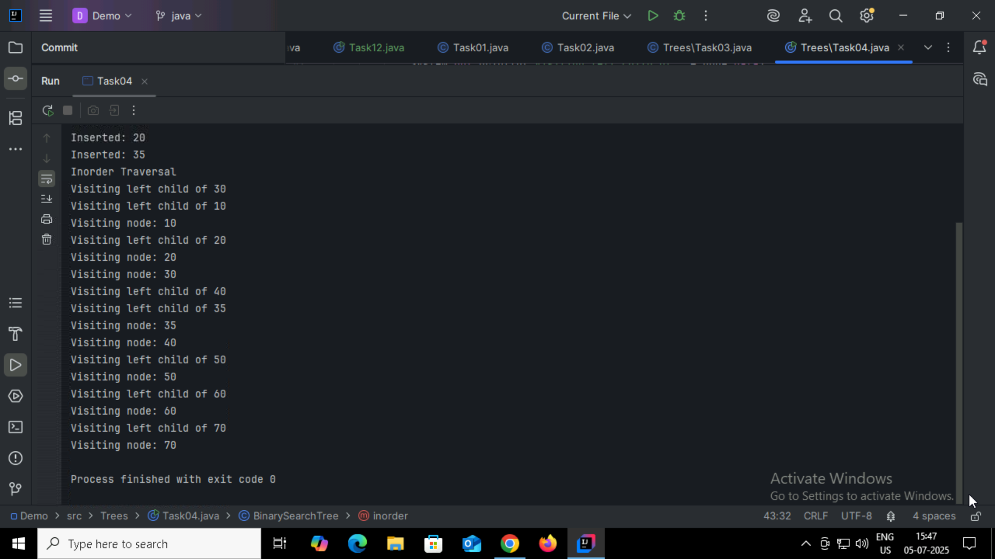

Task05:

Applications of Tree:

Binary Search

Database Indexing

GUI Hierarchies

XML/JSON Parsing

Routing Algorithms

Compiler Design

Priority Queues

Task06:

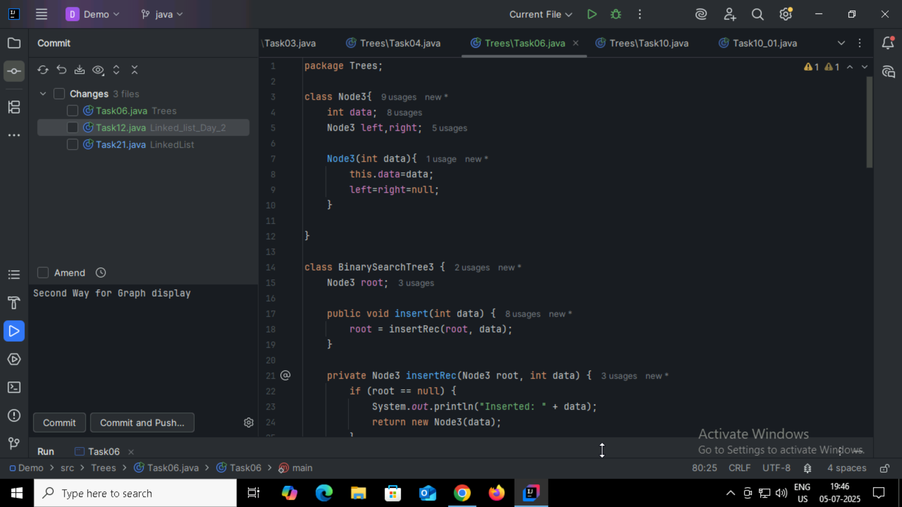

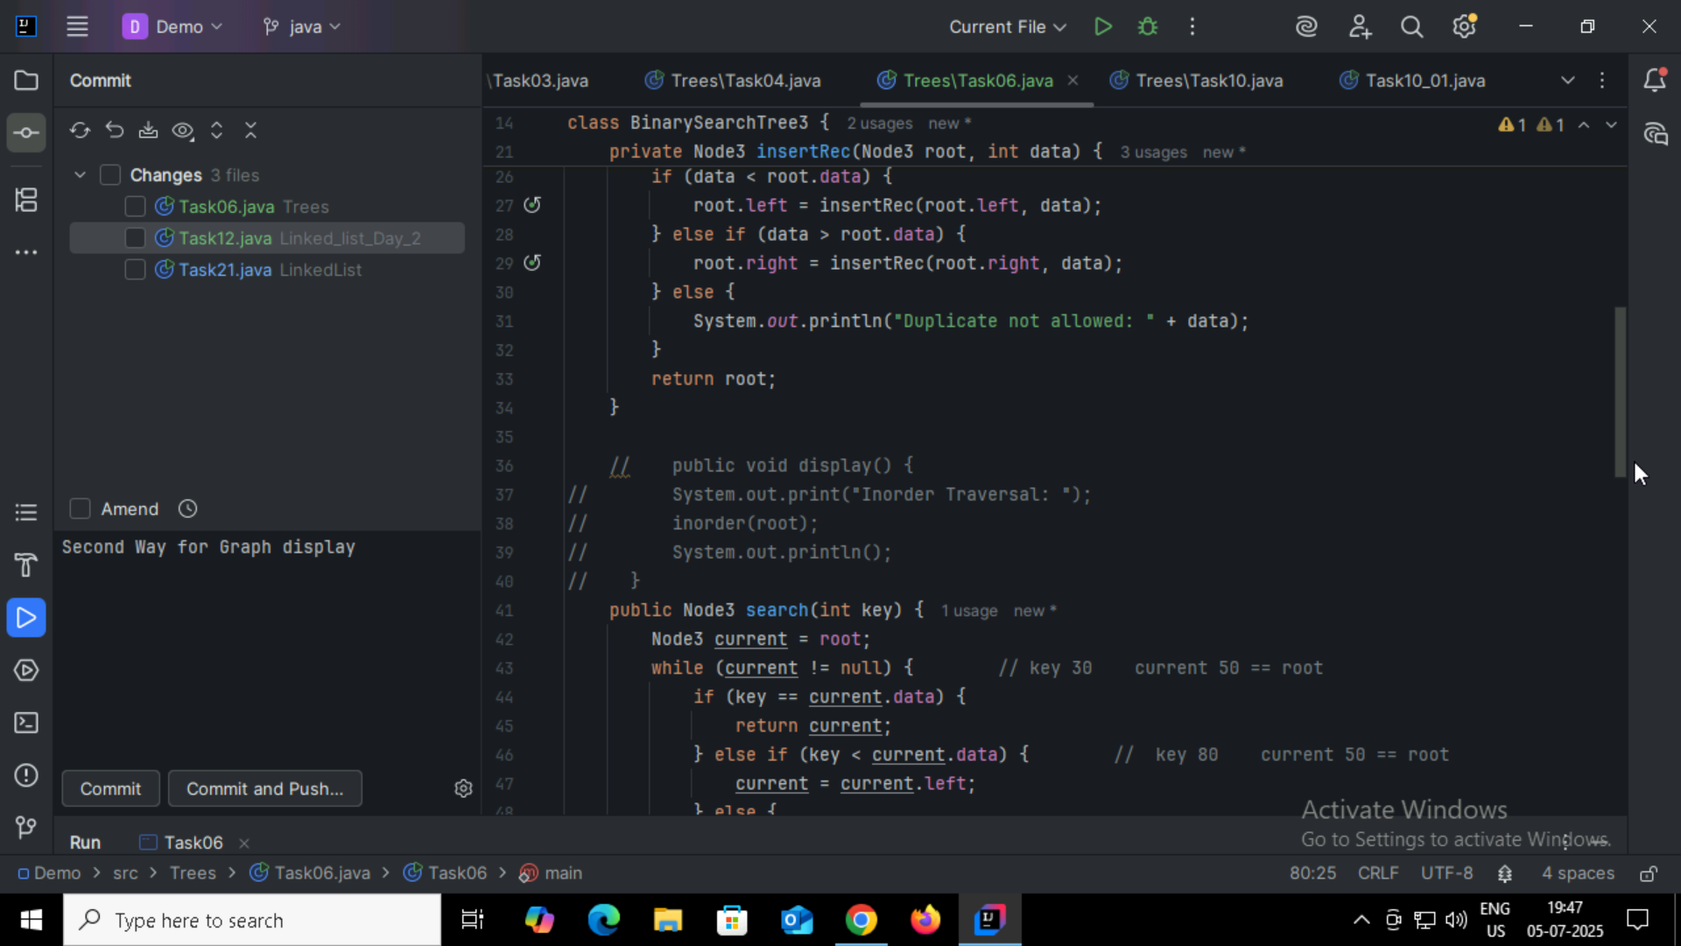

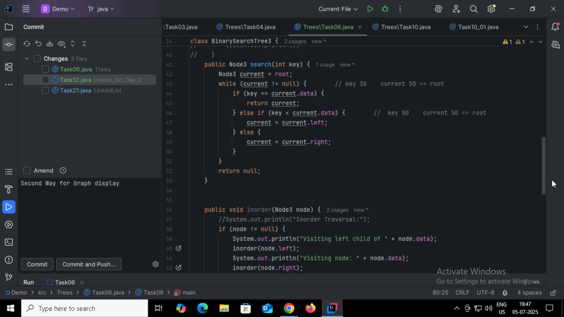

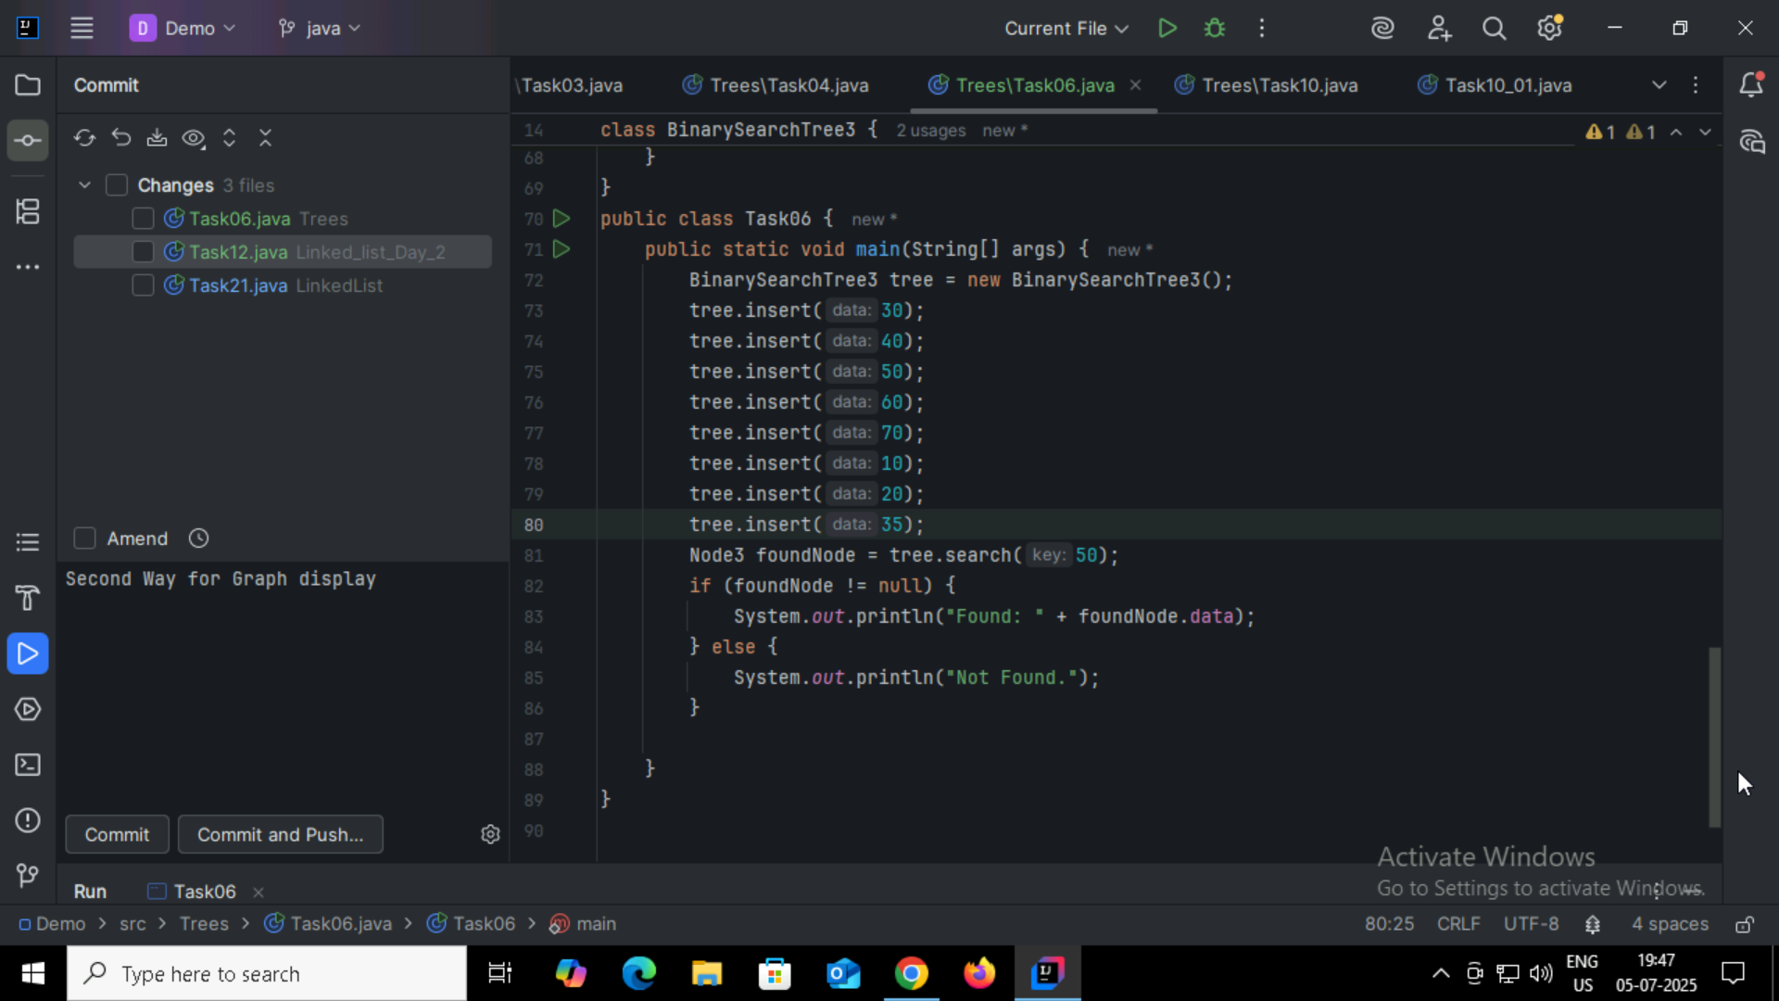

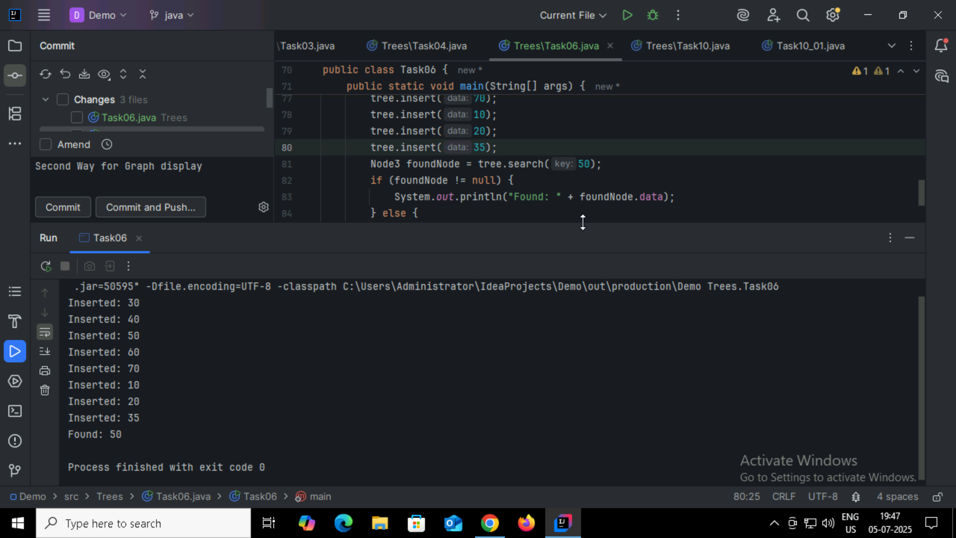

Task07:

Types of Binary Trees

Full Binary Tree

Complete Binary Tree

Perfect Binary Tree

Balanced Binary Tree

Degenerate (or Skewed) Binary Tree

Binary Search Tree (BST)

Threaded Binary Tree

AVL Tree

Red-Black Tree

Expression Tree

Task08:

Applications of graphs

Social Networks- Facebook, LinkedIn: friends, followers, connections

Google Maps, GPS Systems -Routes between cities, shortest paths, traffic optimization

Computer Networks - Internet routing, network topology, data flow

Airline Routes - Airports as nodes, flights as edges

Web Crawlers - Hyperlinks form a directed graph of the internet

Electric Circuits - Components and connections form graph structures

Supply Chain & Logistics -Distribution networks and delivery routes

Task09:

Types of graphs

Property - Type Examples

Direction - Directed, Undirected

Weight - Weighted, Unweighted

Cycle- Cyclic, Acyclic, DAG

Completeness - Complete, Sparse, Dense

Special Structure - Bipartite, Tree, Planar, Multigraph

Task10:

